**PROPELLOR**

**Performed steps**

1. Open up simulation.
2. Insert variables.
3. Calculate with the same variables.
4. Compare results.

**Results**

This is the result with the simulation:

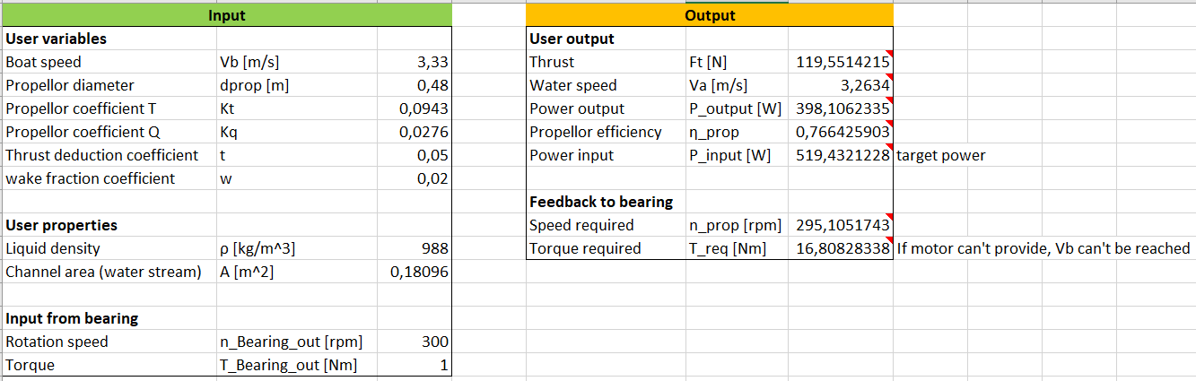

This is the result of the calculations:

$$F_{t}=ρ*n^{2}\left[rps\right]*d^{4}*K_{T}=988*{\frac{295,63}{60}}^{2}*{0,48}^{4}*0,0943=119,6[N]$$

$$P=F*v=119,6*3,33=398,3$$

**Conclusion**

In conclusion, the outputs from the simulation match the outputs from the calculations. Therefore, the hypothesis:

*“the propellor simulation has the same output as the calculations”*

is correct and the simulation works as intended.